**Basic Lore**

In the beginning of history, the god of life and order Akhar separated the mists of chaos by placing his staff in the middle island to create a place for plants, humans and animals to thrive, the monsters and old gods that live in the mist didn’t like it so they tried to restore the chaos mist, but Akhar got the humans to create the tower of light, where a part of his power is charges the field to keep the mist out. He then formed the Sun and Moon to watch over the day and night, to make light and reflect light.

When the staff was placed, all monsters fled and many of the old gods died, the monsters that survived turned into the animals, plants arose from the ground, and man started increase in number.

10’000 years later 12 massive empires rose and fell, cultures and nations formed all over 5 islands, trading, and conquering each other. Now an empire on the verge of falling is face with the return of the chaos mist, the Emperor must reignite the dying tower that his palace was built around. The Emperor has sent out a request to a powerful mage for a rune to reignite the tower. He has also invited several diplomats, warriors and assassins to calm down the chaos within the city. But things go south, the rune was delayed and attacked by pirates, and the warriors were struck down by the growing mist. 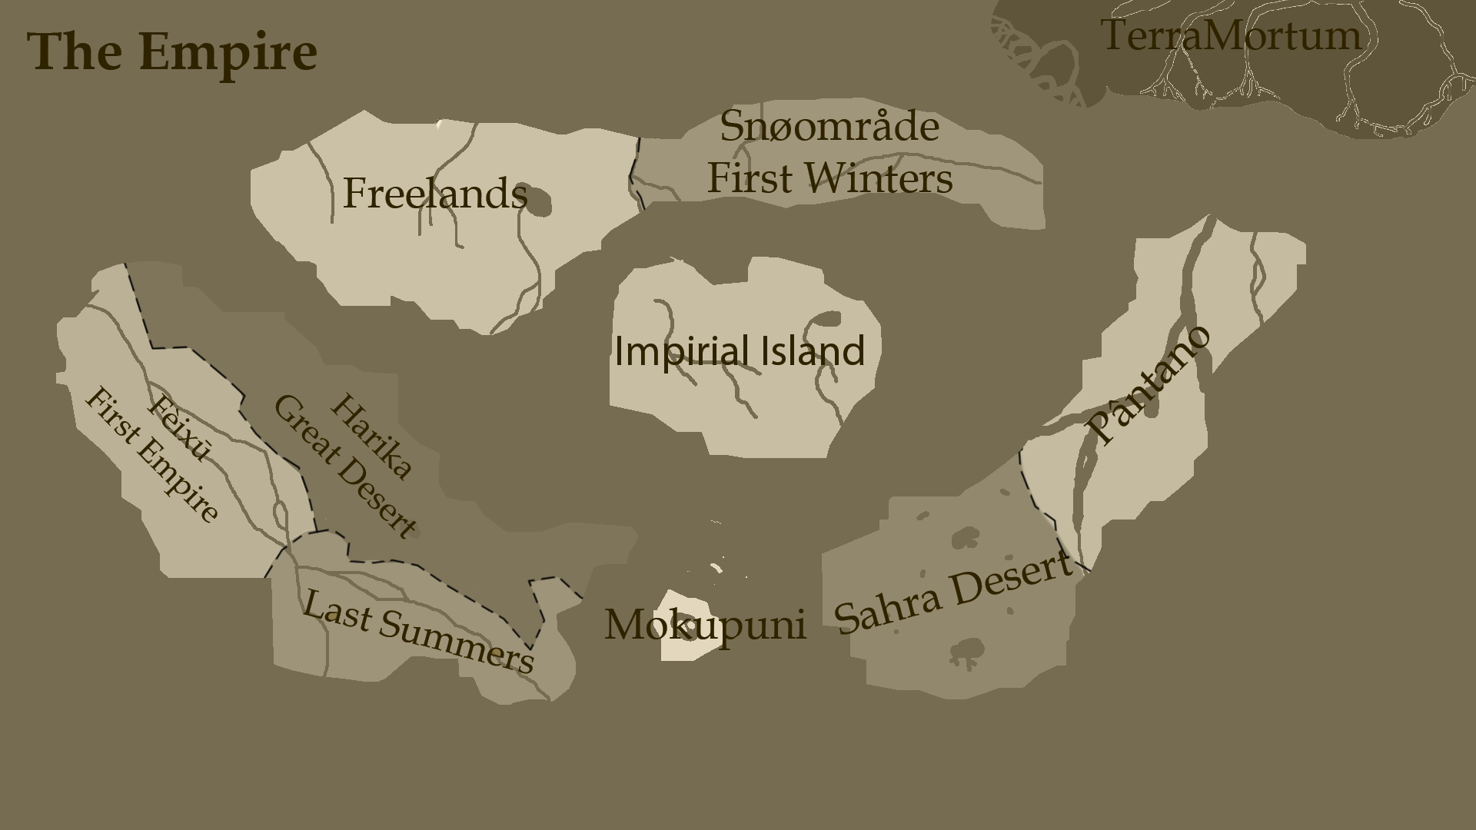

Rebellion: After decades of oppression, crippling taxation, mass poverty, and over policing, 12 businessmen, nobles and politicians got together to petition the Emperor, to lower taxation and lift the lighten the police, they were charge with treason. Half of them escaped, including two noble who used their armies to overthrow the Emperor, the politicians got the people to rise up, and the businessmen, sold cheap weapons, automatons and ammunitions to the rebel armies. Two years later, chaos in the Imperial city.

Witch Clans: the clans formed 10 years ago, believing the old gods to be the rightful rulers of the land they cursed the Tower and started to form the Chaos mist bringing monsters into the land.

